Data Structures

Stack
A linear data structure which acts similarly to a stack of books. The last item you added to the stack is the only item you can access/remove. One-ended meaning the data can only be added (pushed) or removed (popped) from one end. It is described as LIFO, or Last In First Out.
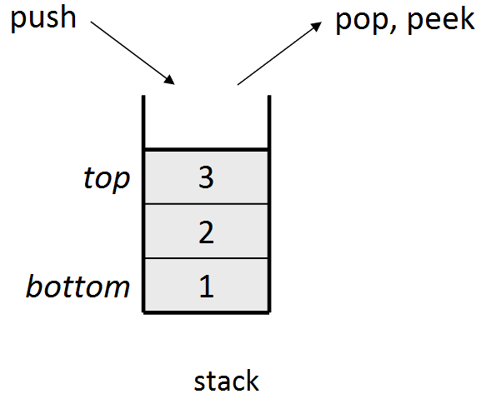

Real World Applications
- Compiler syntax check for matching brackets.
{ { { { } } } }
You can scan through each character in code and add each open bracket to the stack. When there's a close bracket, remove an item from the stack and it will be the corresponding bracket.
- Keeping track of previous function calls (stack trace)
- Used to do a Depth First Search (DFS) on a graph

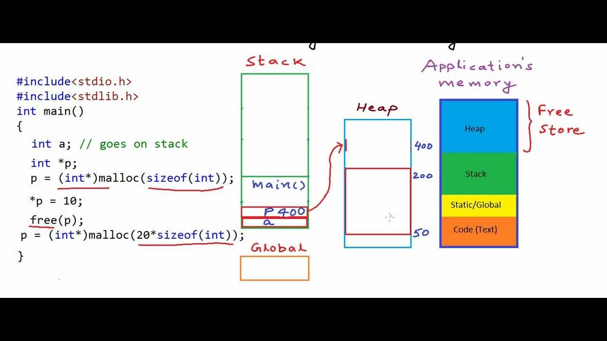
In computers, memory is accessed and stored via data structures. A heap is used for free memory, as this allows the computer to quickly access the highest or lowest memory address.
There are sections for instructions, global variables, in an application's memory and these are typically low addresses. Then in the stack resides function calls and local variables.

The stack is used for function calls because the natural order of function execution results in the program entry-point (main function) also being the program exit. So when a function is called, it is added to the top of the stack, until the function completes:

int a = 1;
void doSomething2() {
int c = 4;
return;
}
void doSomething1() {
doSomething2();
}
int main() {
int b = 1;
doSomething1();
}
Stack
Static/Global
doSomething2()
c = 4
doSomething1()
main()
b = 1
a = 1
If your application takes up more memory than was allocated at compile time, e.g. you had an infinite recursion, you'll get Stack Overflow error.

Queue
The queue is another one-dimensional data structure, but is a FIFO accessed data structure. Meaning, the First item In is the First item Out. They are just like queues in real life, really. Adding to a queue is named Enqueue, and removing is called Dequeue.
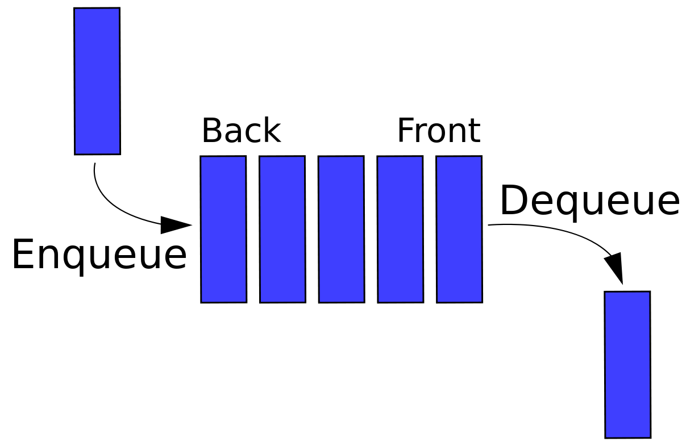

Real World Applications
- Used in a breadth first search (BFS) algorithm. Helps in traversing trees/graphs
- Request scheduling
- Any time you need a first-come first-served approach, e.g. song queue on spotify, wait list for selling digital products

Linked Lists
A sequence of objects which are linked by pointers… Singly linked meaning the nodes only point to one following or previous node, or doubly linked meaning each node points to their following and previous nodes. A doubly linked list, unlike the singly linked list is traversable back and forth.
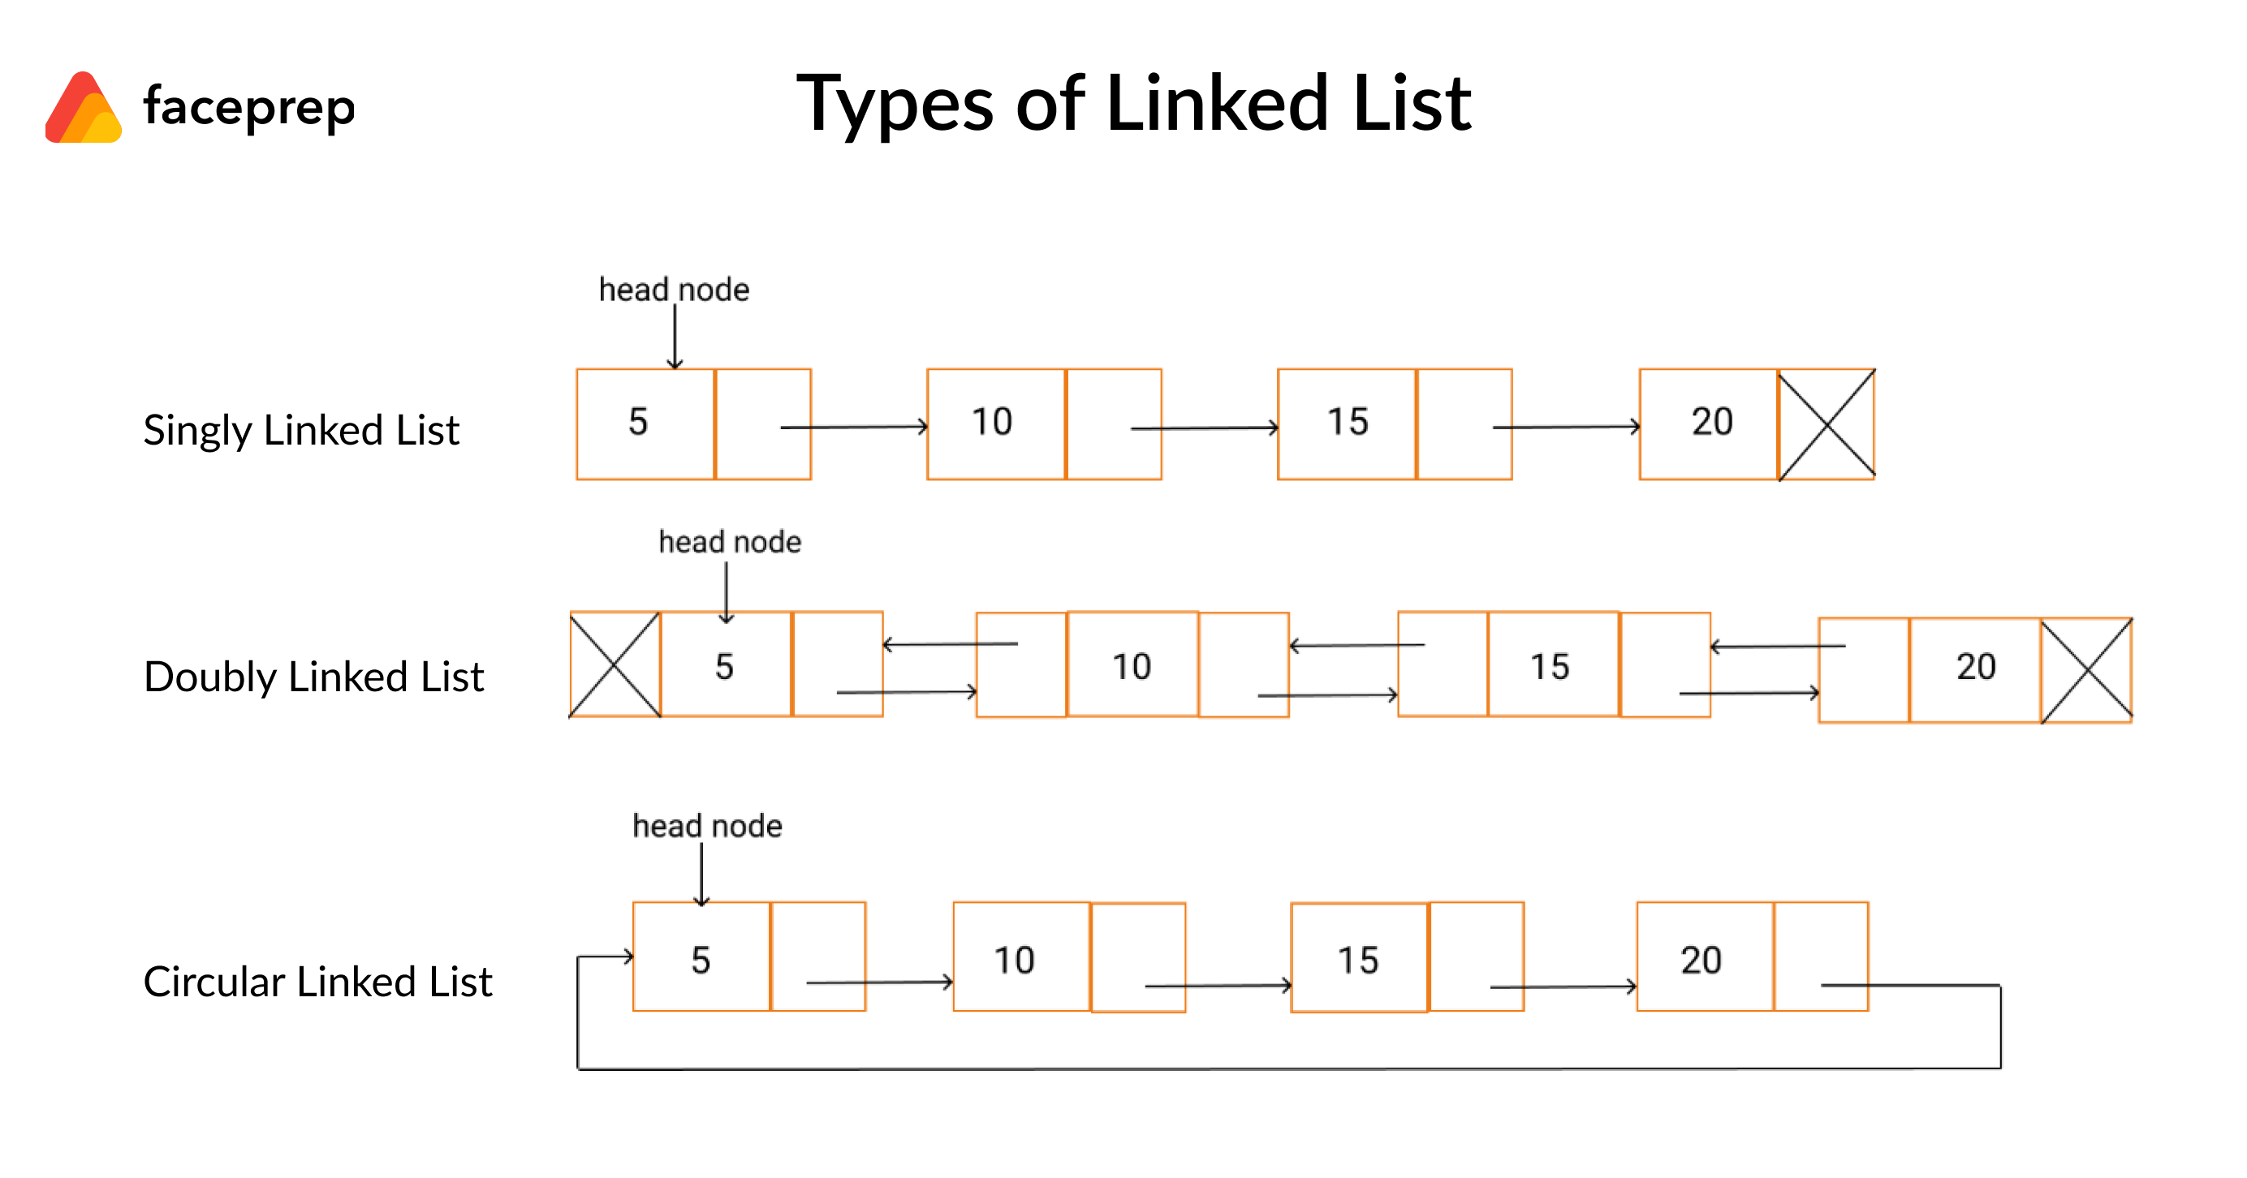
Real World Applications
- Great foundation for other data structures, e.g.
  - Stacks, queues, binary trees are essentially linked lists with more/less complexity
- Browser cache will use data structures similar to doubly linked lists along with a currentIndex property to access the history and go back/forth between cached pages

Reverse a singly linked list
void reverse(struct Node** head)
{
struct Node* prev = NULL;
struct Node* currentNode = *head;
struct Node* next = NULL;

while (currentNode != NULL)
{
// Store next node in the temp pointer
next = currentNode->next;
// Reverse the current node's pointer
current->next = prev;

// Move temp pointers one position ahead
prev = currentNode;
currentNode = next;
}
}

Trees
A hierarchal set of linked nodes. There is always a root node in a tree structure. The below tree shows 2 at the top as the root node.
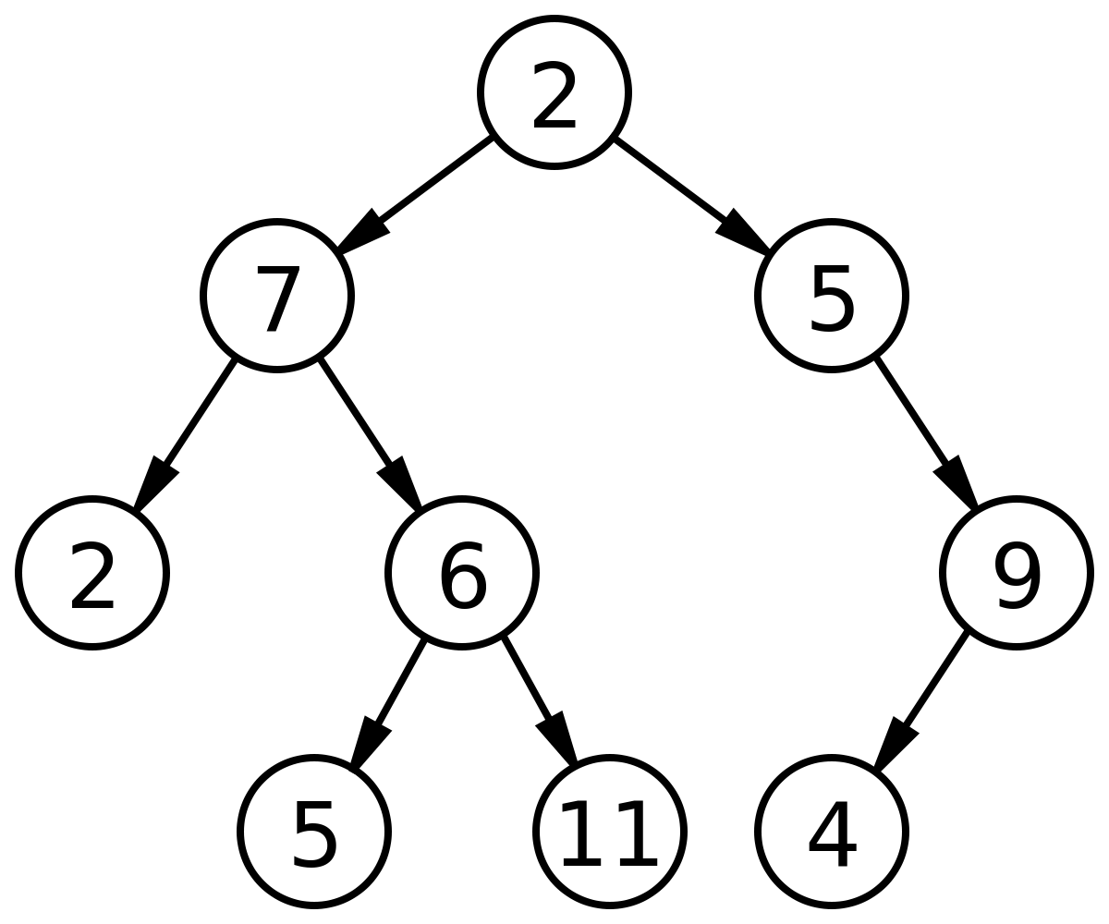
- The node at the top is known as the root of the tree.
- All nodes with children are called parents.
- A node with no children is a leaf.
- In standard trees, there may be as many children as necessary.

Real World Applications
- A file system is a tree. You can think of directories, folders and subfolders as parent nodes, and files as leaves.

Binary Search Tree (BST)
Is an “ordered” binary tree. Meaning the nodes to the left cannot have a higher value than the nodes to the right. The root node cannot be the smallest value.
The left subtree has smaller elements and the right subtree has larger elements.
- Can only ever have at most 2 children.
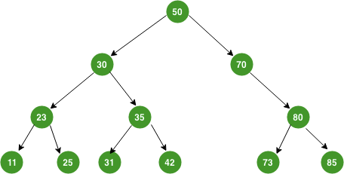

Real World Applications

Heap
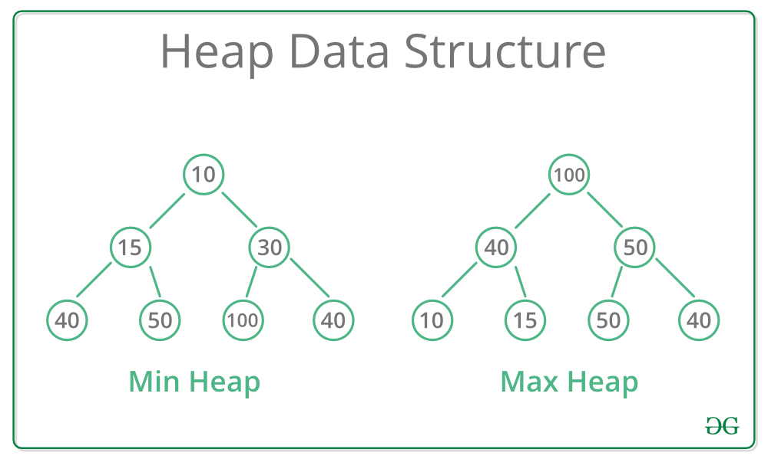
A tree-based data structure, which essentially orders it's nodes.
In a Max Heap, the parent node must always be greater then or equal to either of their child nodes.
In a Min Heap, the parent node is always less than or equal to their child nodes.
Real World Applications
- Used in djikstra's algorithm
- When you need quick access to the max/min value of data

Hash Tables
A hash table is a collection of key-value pairs. The indexes are calculated with a hash function to figure out which index to place the key in. The formula for computing an index can be anything, but should use ASCII codes for alphanumeric values, and may include the number of elements, n.

Hash Function
Should:
- Minimize collisions
- Distribute values uniformly
- Be quick to calculate
- Resolve any collisions
The hash function should provide a uniform distribution of hash values, otherwise there can be collisions. If there is a uniform distribution of hash values (no collisions), then the time to access data is always constant, or O(1). Collision occurs when the hash function for a key returns the same index as an already existing key.

Open Addressing to Avoid Collision
To avoid collision, find a new index.
Collisions can simply be overcome by linear-probing, which scans through the array for the next available index. So, to retrieve a key-value which was placed in an index further along the line, you will have to again scan in a linear fashion.
You may also use Quadratic probing, which will take the amount of failed attempts to find the next index, and square it;
New index = (failed attempts to find the next available index)²

Closed Addressing to Avoid Collision
To avoid collision, store a list of items at each index.
Instead of storing objects at their respective indexes derived from the hash function, you store a pointer to a linked-list in this index, with the object you wish to store in the first linked-list node. Now, whenever you need to store an object into an occupied index, you just append this to a new linked-list node.

Sometimes, because of collisions, only a fraction of the hash table may be occupied, resulting in empty indexes. The ratio of items stored, compared with the total array size is known as the Load Factor.
Load Factor = Total number of items stored / Size of array

Time Complexity
Best-Case scenario for accessing data: O(1)
Worst-Case scenario, where the hash table has collision and you need to scan through the whole table: O(n)

